OS Lab Assignment - 15

**Submitted By -: Rohan Kumar**

**Section -: C**

**Roll No. -: 52**

**Subject -: Operating System Lab (BCSC 0803)**

**Submitted To -: Ms. Nidhi**

Ques – Write a shell script to print a multiplication table of a given number

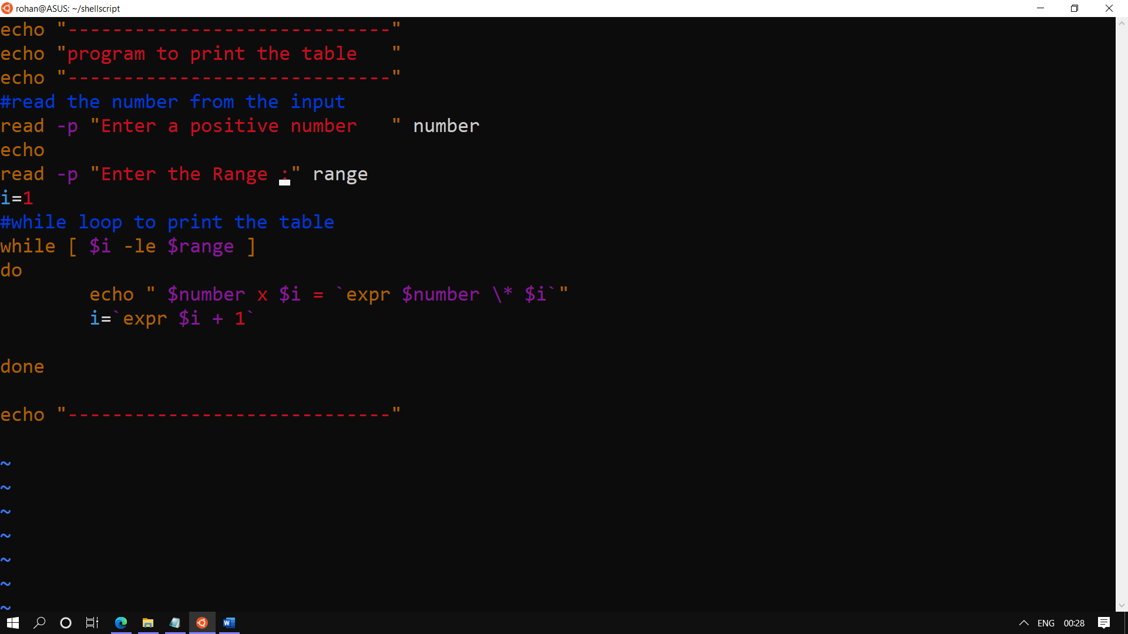

The output:--

